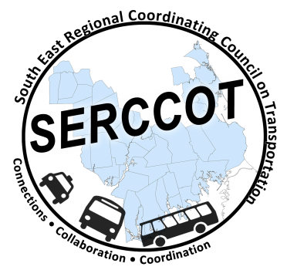
Southeast Regional Coordinating
Council on Transportation (SERCCOT)
Agenda
Tuesday, August 11, 2015
9:30AM – 11:00AM
NOTE TIME CHANGE
SRPEDD, 88 Broadway St., Taunton

- Welcome & Introductions
- Meeting Minutes review from July
- Review of Tufts Health Foundation grant – Janet/Mary
  - LOI Submitted, copies of final available
  - Notification of Invitation – August 19
  - Next steps if asked to proceed
- Wareham Collaboration Meeting August 11th - Angie
  - Community meeting scheduled
    - Review agenda
- Fall Forum on Education/Employment
  - Location finalized
  - Outreach plan update - Angie
    - Review of invite list
  - Agenda – who/how
- Summary & Review of action items

