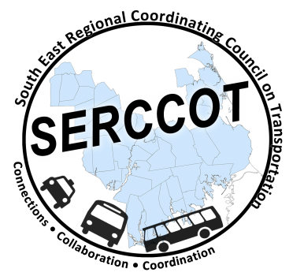
Southeast Regional Coordinating
Council on Transportation (SERCCOT)
Agenda
Tuesday, February 16, 2016
9:00AM – 10:30AM
Coastline, 1646 Purchase St, New Bedford, MA 02740
- Welcome & Introductions
- Meeting Minutes review from January
- Work Grants review for Southeast - Angie
- Transit Planning for All: Demonstration Funding Announcement - Rachel
- Marketing Toolbox – Mary
  - Update on progress
  - Subcommittee
- Community Transit Grant Program - Angie
- Fall Forum on Education/Employment
  - Evaluations/Table Notes Update
  - Review of Action Items
    - MassRides/Nurides Materials
    - Community Colleges Transportation
- Newsletter – Action Items information to forum participants
- Summary & Review of action items

