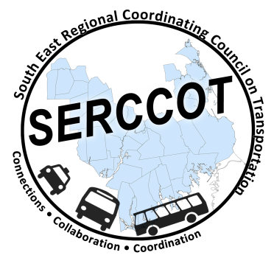
Southeast Regional Coordinating
Council on Transportation (SERCCOT)
Agenda
Tuesday, January 12, 2016
9:00AM – 10:30AM
SRPEDD, 88 Broadway St., Taunton

Happy New Year!

- Welcome & Introductions
- Meeting Minutes review from late October
- Fall Forum on Education/Employment
  - Summary of world café notes
  - Summary of forum evaluations
  - Discussion of Next Steps
- Status of Marketing Tool Box & Next Steps
- Status of Wareham Coordination Project & Next Steps
- Review of Feedback from Tufts LOI
- Revitalizing council attendance from South coast area
- Summary & Review of action items

