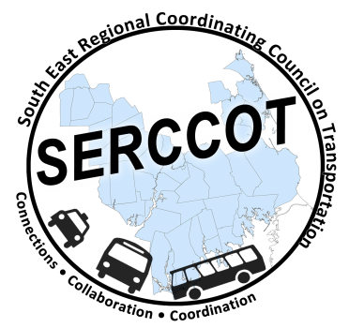
Southeast Regional Coordinating
Council on Transportation (SERCCOT)
Agenda
Tuesday, July 14, 2015
9:00AM – 10:30AM
SRPEDD, 88 Broadway St., Taunton

- Welcome & Introductions
- Meeting Minutes review from June
- Review of Tufts Health Foundation grant
  - LOI, Scope of consultant, timeline for project – Janet/Mary
    - Next Steps
  - Outreach to Banks – Angie
    - Next Steps
- Wareham Collaboration Pre-meeting June 17th
  - Community meeting attended - Steve/Janet/Angie
    - Next Steps
- Fall Forum on Education/Employment
  - Location review – Joe for BCC
  - Outreach plan update - Angie
    - Creation of invite lists –who/how
  - Agenda – who/how
- Summary & Review of action items

