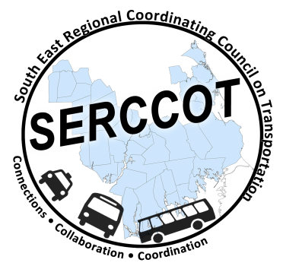
Southeast Regional Coordinating
Council on Transportation (SERCCOT)
Agenda
Tuesday, June 14, 2016
9:00AM – 10:30AM
SRPEDD, 88 Broadway, Taunton, MA 02780

- Welcome & Introductions - Janet
- Meeting Minutes review from May – Janet
- Consumers Outreach Next Steps – Angie
Sept/Oct – Develop Survey to be sent to consumers
Nov/Dec – Survey out
Jan – Survey results tabulated

- Directive Tools Brochures Update – Mary
5 separate brochures – 1) Medical; 2) Disability; 3) Senior; 4) Students/colleges;
5) Commuter

- Newsletter Update – Action Items information to forum participants – Julie
- Plan for SERCCOT meetings moving forward
- Summary & Review of action items

