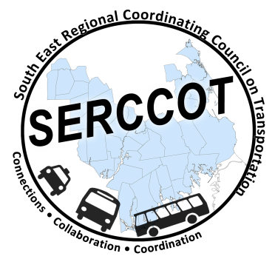
Southeast Regional Coordinating
Council on Transportation (SERCCOT)
Agenda
Tuesday, June 9, 2015
9:00AM – 11:00AM
SRPEDD, 88 Broadway St., Taunton

- Welcome & Introductions

- Meeting Minutes review from May

- Review of Tufts Health Foundation grant - Janet/Mary
  - Other supporting funds – Banks - Angie
  - Letter of Inquiry, Scope of consultant, timeline for project

- Wareham Collaboration Pre-meeting June 17th
  - SERCCOT members to attend - Steve/Janet/Angie

- Fall Forum on Education/Employment – Initial Discussion/Planning

- Summary & Review of action items

