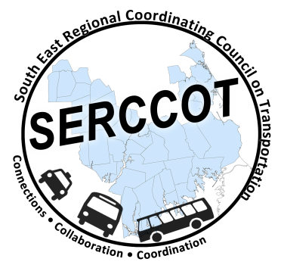
Southeast Regional Coordinating
Council on Transportation (SERCCOT)
Agenda
Tuesday, October 25, 2016
9:00AM – 10:30AM
SRPEDD, 88 Broadway, Taunton

- Welcome & Introductions
- Meeting Minutes review from September
- Old Business
  - Wareham-New Bedford Connection Update
  - Ride Match Update
  - Design Thinking/Consumers Outreach Project
  - Marketing Brochures Update
  - Newsletter Update
- New Business
  - Social Responsibility Network out of Attleboro / Norton
- SERCCOT Meeting Date and Locations Update
- Summary & Review of action items

