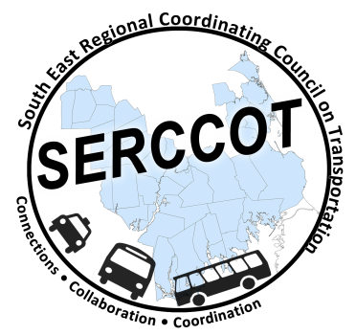
Southeast Regional Coordinating
Council on Transportation (SERCCOT)
Agenda
Tuesday, October 27, 2015
9:00AM – 10:30AM
SRPEDD, 88 Broadway St., Taunton

- Welcome & Introductions
- Meeting Minutes review from early October
- Fall Forum on Education/Employment
  - Current registration status
  - Scenarios review
  - Materials Status
    - Agenda/Powerpoints/Intro.
    - Food
    - Folders & Name tags
    - Easels
    - Audio/Visual needs
    - Room set up
- Other
    - Registration desk helpers
    - Table facilitator and note taker assignments
    - Seating Plan
- Summary & Review of action items

Items for future meetings: Tufts LOI feedback, Wareham coordination project status, future meeting site

