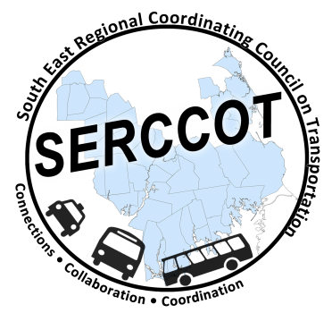
Southeast Regional Coordinating
Council on Transportation (SERCCOT)
Agenda
Tuesday, October 6, 2015
9:00 – 10:30AM
SRPEDD, 88 Broadway St., Taunton

- Welcome & Introductions
- Meeting Minutes review from September
- Fall Forum on Education/Employment
  - Review of invite list
  - Agenda
  - Food/Supplies Needed
  - Pre-Survey
    - Education
    - Employment
  - Scenarios/Case Stories
  - Discuss World Café Process
- Summary & Review of action items
- Next Meeting – November 10th

