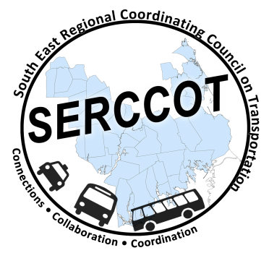
Southeast Regional Coordinating
Council on Transportation (SERCCOT)
Agenda
Tuesday, September 20, 2016
11:00AM – 1:00PM
Coastline Elderly Services, 1646 Purchase St., New Bedford

- Welcome & Introductions
- Meeting Minutes review from June
- Work Grants Project Update
- Community Transit Grant Program (CTGP) Award Update
- Ride Match Update
- Design Thinking Update
- Consumers Outreach

- SERCCOT Meeting Dates Update
- Marketing Brochures Update

- Newsletter Update
- Summary & Review of action items

