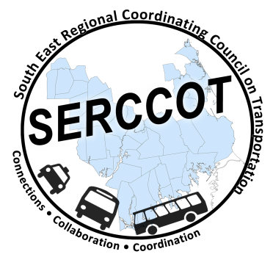
Southeast Regional Coordinating
Council on Transportation (SERCCOT)
Agenda
Tuesday, September 8, 2015
9:00 – 10:30AM
SRPEDD, 88 Broadway St., Taunton

- Welcome & Introductions
- Meeting Minutes review from August
- Review of Tufts Health Foundation Grant – Janet
  - Next Steps
- Wareham Collaboration Meeting from August 11th - Angie
  - Summary of Meeting
- Fall Forum on Education/Employment
  - Review of invite list - Angie
  - Agenda
  - Pre-Survey
    - Education
    - Employment
- Newsletter idea – who/what/when
- Summary & Review of action items

